Introduction
Literature Review
Methodology
Research methodology entails the detailed approaches applied in research to comprehensively answer the research questions and tackle the research objectives. Text analytics methodology was applied to analyse speeches made by different party members in Britain. Text analytics is based on language understanding, symbols, pictures, and any other information presented in text form. The idea of Text mining attempts to bring out the relevant information from the natural language. This idea of Text mining is rapidly increasing in the field of Text mining. Precisely Text mining marks the process of examining the text in order to bring out the relevant information to be used for a particular purpose.
Further, text is unformed, ambiguous, and hard to process compared to the data kept in data bases. Nonetheless, during the formal exchange of information text is the prevalent communal method used in modern world. Text mining commonly focuses on texts whose purpose is communicating the actual information and that the stimuli of attempting to bring out information from those texts of course is captivating even though success is incomplete. In the 1980s Text mining using manual methods was first used. For this reason therefore, it became clear that these manual methods were costly as well as labor intensive. In addition these manual methods consumed a lot of time in processing quantity of information growing.
For a period of time, creation of programs happened to succeed and this helped in processing the information automatically. For this reason there has been prominent progress for the last few years. Study on Text mining focuses on growth of statistics and mathematics techniques, linguistic and pattern recognition techniques. All these techniques helps in determining the unstructured information, and removal of useful and high quality data for the purposing of making the text easy to search. Text document entails characters which when put together makes words, which can later merge to bring about phrases. Therefore all these are syntactic characteristics that when put together they amount to already defined concepts, categories, and meanings. It a must for Text mining to recognize, remove and make use of the information. Searching at a higher level entails searching for semantic patterns rather than searching for words. Procedure of Text mining entails a chain of activities to be conducted for the purpose of competently mining the information. The activities are; Pre-processing which entails a chain of steps as follows.
Step 1. Step one entails cleaning up of the text. Under this, any inessential information is extracted. This has to do with extracting ads found in web pages, as well one has to normalize the text from binary format and now focus with tables, formulas, and figures.
Step 2. It entails tokenization. Tokenizing is attained by breaking text found on white spaces and punctuation marks not owned by abbreviations pointed out in previous stage. Under this step we also have part of speech which entails tagging part of speech. The word tagging means assigning word class to each token. Precisely, the input of this is offered by a text that is tokenized. Those taking the responsibility of tagging have to cope with words that are unknown and word-tag mappings that are ambiguous. ENGTWOL is a rule based technique that work on dictionaries possessing word forms along with the associated Part of Speech(POS) labels as well as morphological and syntactic properties. As well ENGTWOL works on careful conditions rules to select the important labels during application.
The other step involves transformation of text. Text document entails word properties that it contains and their occurrences. Bag of words and vector space are two main perspectives of document representation.
The next step involves feature selection or what is also known as variable selection. This step entails the procedure of choosing a subset of relevant properties which are to be used in creating the model. Key assumption when using feature selection is that data possesses a lot of unessential features. These unessential features gives zero extra information and they provides unnecessary information. In addition, feature selection technique is a subcategory of general field of feature extraction.
Data mining is the next step and it entails Text mining process jointly with traditional mining process. Structured data base uses classic data mining and gives results observed from previous steps. Final step involves evaluation which entails checking the correctness of the results. After correcting, generated result can be used as input for the next set of series.
Sampling was applied to obtain a representative sample from the entire dataset. The original dataset was too huge measuring about 2.3 GB. Generally, such a dataset would be impossible to analyses with a standard CPU. A sample of 10,000 observations were randomly ample from the data that was used for the analysis. Data filtering was also conducted to account for the observation between 2005 and 2010. The concepts of correlation analysis and word frequency formed the basis and foundation for the data analysis. Word frequency analysis is a text analytic methods applied to investigate the occurrence of words in a text document. This is done by constructing word cloud and data frames for most frequent words.
Data Analysis and Results
Descriptive Statistics
Descriptive statistics involves the computation of statistical charts, figures and graphs. This helps the researcher to explore the association between the data variables and the existing pattern. The computation of means, median, maximum, minimum, and standard deviation for the basic of descriptive statistics. Further exploring the data prior to data analysis aids to data transformation as well as data cleaning process. Bar graphs, histogram are commonly used in data distribution assessment. Data cleaning ensures the data is in the right form and format for analysis. The following charts describes the variable distribution of the data.
The dimension function is used to identify the data dimension, while the structure function is used to give the structure of the data variables. 10000 rows and 11 variables were used. Data cleaning form the first step of any data analysis. Table bellows shows the distribution of missing values in the data.
Missing values in the data.
## na_count1
## X1 0
## date 0
## agenda 10000
## speechnumber 0
## speaker 4
## party 343
## party.facts.id 465
## chair 0
## terms 0
## text 0
## parliament 0
## iso3country 0
The variable agenda was 100% missing, the variable was dropped and the other missing cases dropped from the data.

Parties Distribution
##
## APNI Con DUP GPEW Lab LibDem PlaidCymru
## 2 3281 79 5 4938 1033 44
## Respect SDLP SNP UKIP UUP
## 2 28 111 5 7
Most of the observation were present in the labor party and congress party with a total of 4938 and 3281 speeches respectively. The least debating parties are APNI and Respect having 2 speeches each.

party | Number of Debates
APNI | 2
Con | 3281
DUP | 79
GPEW | 5
Lab | 4938
LibDem | 1033
PlaidCymru | 44
Respect | 2
SDLP | 28
SNP | 111
UKIP | 5
UUP | 7
Investigating the number of characters in the speeches, gives the length of the speeches made. Generally we would expect some speeches to be short, moderate and other long. It is evident that the larges speeches are from the congress and labor part as indicated by the histogram below.
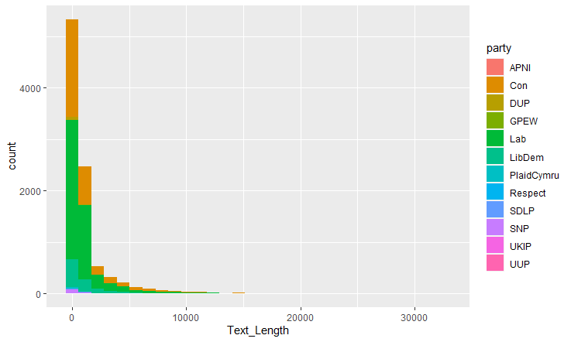
Further, the histogram also indicates that majority of the speeches were short since the histogram depicts a right skewed distribution.
The created word cloud from the speeches made by the congress MPs indicated that, some words were frequently mention. Although these words also have been frequently mentioned by other party members, they were reserved since they portrayed a distinctive message that is common across all the parties. The words of interest as formulated on the hypothesis were then considered and analysed.

Fig 1.0: Word cloud generated from Congress MPs speeches.
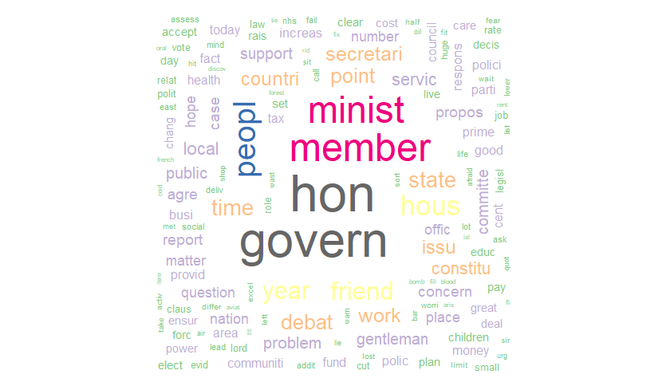
Fig 1.1: Word cloud generated from Labour MPs speeches.
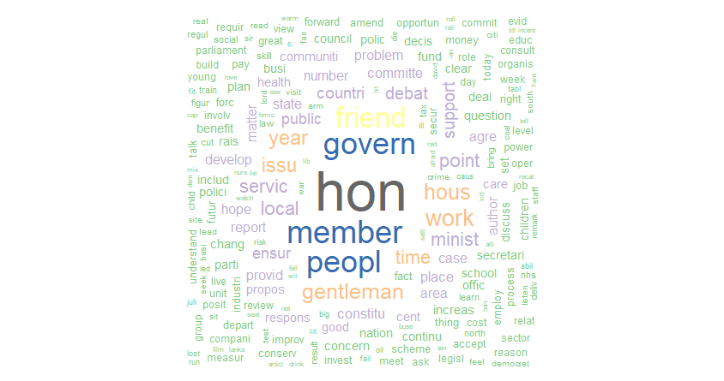

 | words | Freq
hon | hon | 11893
govern | govern | 7980
member | member | 7364
peopl | peopl | 6690
friend | friend | 4991
minist | minist | 4954
hous | hous | 4699
year | year | 4346
work | work | 4058
time | time | 3576
issu | issu | 3559
point | point | 3346
local | local | 3233
gentleman | gentleman | 3157
debat | debat | 2976
servic | servic | 2889
support | support | 2841
countri | countri | 2816
state | state | 2674
secretari | secretari | 2192

Accessing the frequency of words of interest in each party speeches
Occurrence of the words women, rape, sexual, exploit in the congress speeches
## words Freq
## women women 130
## sexual sexual 32
## rape rape 26
## exploit exploit 22

Occurrence of the words work, education, equal in the labour speeches
## words Freq
## work work 2385
## educ educ 587
## equal equal 202

Occurrence of the words rape and sexual in the labour speeches
## words Freq
## sexual sexual 67
## rape rape 36

Accessing the correlation of the key words, correlation coefficients of above 0.5 were identified between the key words such as rape with other words. Correlation analysis helps to identify the most probable word to occur whenever a certain word is mentioned. The higher the correlation the higher the occurrence of the two words. Likewise, the lower the correlation, the less likely the words to occur together.
## $member
## hon
## 0.77
##
## $work
## numeric(0)
##
## $rape
## anyone brox comb
## 0.60 0.51 0.51
## criticism difficult quest
## 0.51 0.51 0.51
## finetooth forgotten help
## 0.51 0.51 0.51
## inadequate individual intercour
## 0.51 0.51 0.51
## overstep reassurance sport
## 0.51 0.51 0.51
## Statute test unmeritori
## 0.51 0.51 0.51
## Wollaston attribute centre
## 0.51 0.45 0.45

## $sexual
## centresinde pass
## 0.54 0.54
The variable rape had the highest number of highly correlated words.

Conclusion
A comprehensive text analysis was performed on speeches made by female MPs of different parties. The main focus was centred on the Conservative and Labour party. A clear distractive difference was identified between the speeches made by conservative and labour party members. It is evident that the conservative party member debate more than the labour party member’s. A frequency tables of the debates made by conservative and labour party MPs indicated that a total of 4178 speeches and 3437 were initiated by conservative MPs and Labour MPs respectively. Further, the analysis results indicates that the conservative party members mentioned the names “sexual,”, “rape”, “exploit” more on their debates. The name sexual was mentioned 29 times, exploit 24 times and rape 11 time. Based on the frequent words in text, the ton, agenda, impressing, perception as well as the motive can be derived.
The frequent words said by the Labor party members includes, education, work, equal with a frequency of 458, 1700 and 118 respectively. Interestingly, the word women was also mentioned 339 times in their speeches. Comparing the number of times the word women mention in the speeches, conservative MPs members mentioned the word women 152 times while the Labor MPs mentioned the word women 339 times. This implies that the labor party speeches are more feminist as compared to the conservative speeches.

References.
Anandarajan, M., Hill, C. and Nolan, T., 2019. Practical text analytics. Maximizing the Value of Text Data.(Advances in Analytics and Data Science. Vol. 2.) Springer.
Charteris-Black, J., 2018. Analysing political speeches. Macmillan International Higher Education.
Grimmer, J. and Stewart, B.M., 2015. Text as data: The promise and pitfalls of automatic content analysis methods for political texts. Political analysis, 21(3), pp.267-297.
Laver, M., Benoit, K. and Garry, J., 2015. Extracting policy positions from political texts using words as data. American political science review, pp.311-331.
Neuendorf, K.A. and Kumar, A., 2015. Content analysis. The international encyclopedia of political communication, pp.1-10.
Neuendorf, K.A. and Kumar, A., 2015. Content analysis. The international encyclopedia of political communication, pp.1-10.
Schwarzer, G., Carpenter, J.R. and Rücker, G., 2015. Meta-analysis with R (Vol. 4784). New York: springer.
Silge, J. and Robinson, D., 2017. Text mining with R: A tidy approach. " O'Reilly Media, Inc.".
Welbers, K., Van Atteveldt, W. and Benoit, K., 2017. Text analysis in R. Communication Methods and Measures, 11(4), pp.245-265.

